**SETTING UP VOICE OVER IP CALLING TO INTERNAL AND EXTERNAL SOURCES**

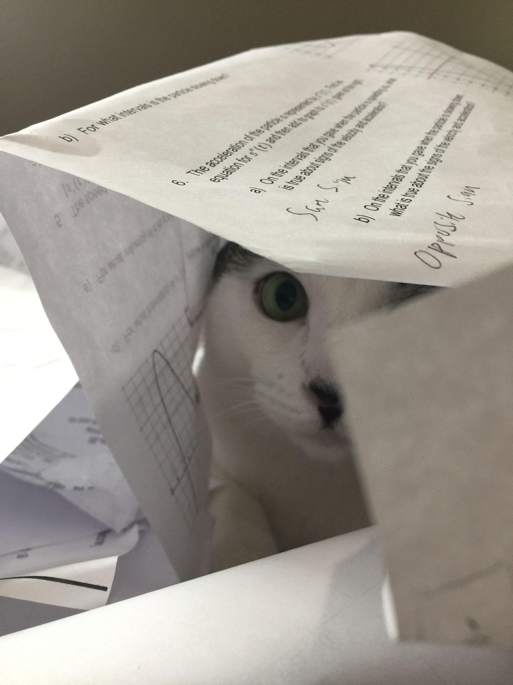

***BY: ALEKSIE SANCHEZ MEDEIROS***

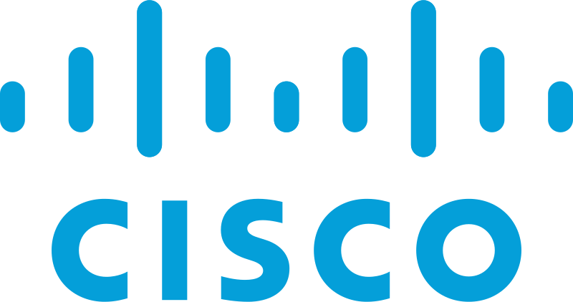

***Purpose***

To learn how to configure internal and external calling over voice over internet protocol using Cisco’s CME to manage voice and data through the network.

***Background****Cisco Call Manager Express is used for allowing communications between IP Phones. Originally, Call Manager was a multimedia manager meant to send video from one point to another as a form of video conferencing. Then it underwent a major change to focus more on routing voice calls over an IP network. By using a Cisco Integrated Series Router which supports telephony and in addition a multitude of other features, connections between phones will be available. This router needs to have the Call Manager software installed on the router itself. The Call Manager software will allow the phones to call each other internally and manage all the calls on a network. On its own, one router can have up to 250 IP Phones. By utilizing a switch the network can divide traffic into separate voice and data traffic and route each accordingly. In addition, some IP Phones come with a miniature switch attached to it allowing for information to a computer or other device to be consolidated through one point.*

*The phones themselves require an IP address in order to allow for communication between them, an administrator can configure it manually or using Dynamic Host Configuration Protocol (DHCP) to assign IP addresses using the router as a DHCP server. DHCP works by having the client, in this case the phone, send a discovery message to the DHCP server and the server responds accordingly with an IP address to give to the client and stores the given address inside the memory. With this same configuration, by adding one command, the router can give the IP of the TFTP server, in the case of this lab the router itself, to download its firmware and configuration file.*

*To allow for external calling the router must have an FXO port on the router which uses an RJ11 connection to connect using the Plain Old Telephone Service (POTS) service, which maps a phone number to a specific voice port on the router to the local Public Switched Telephone Network (PSTN) that the router is connected to..*

***Lab summary***

By the end of the lab, the Cisco 7960 IP Phones and the PCs using those phones as switches were able to communicate with each other and externally, although with a limited range due to the dial plan.

***Lab Commands***

***ip dhcp excluded-address [excluded-address-range-1] [excluded-address-range-2]*** excludes IP addresses from being leased to clients connecting to the DHCP server, this ensures that no confusion will happen in communication such as a computer obtaining the ip-address of another device.

***option 150 ip [router-ip-address]*** is used to specify the IP address of the TFTP server specifically used for VOIP, in order to have the phone obtain the correct firmware and configuration file.

***network [ip-address] [subnet-mask]*** is utilized to specify the range of addresses that can be leased by the DHCP server.

***default-router [default-gateway]*** when using DHCP it enables the client device to receive the default gateway on its own.

***dial-peer voice 99 pots*** enables the device to communicate to external or multiple other Cisco CME routers and create a connection between them.

***destination-pattern 91[2-9].........*** specifies the numbers that the user may dial, adding a range will disable the user from picking numbers outside that range.

***forward-digits all*** dictates how many digits the router will forward to the dial peer.

***telephony-service*** enables the telephony service and allows for configuration of the service.

***ip source-address 192.168.20.1 port 2000*** assigns the IP address and port number used for registering and configuring IP phones

***create cnf-files*** is used to create the files that the phones will use to configure itself when connected.

***ephone-dn 1*** creates a virtual port on the CME system that allows for multiple calls depending on how many ports are defined and allows for it to be configured.

***number 1921*** assigns a number to the phone.

***ephone 1*** represents the actual telephone device connected to the router and enables configuration of it.

***mac-address 0015.2B47.6685*** specifies the mac address of the IP phone which is being configured.

***type 7960*** defines the type of IP phone connected.

***button 1:1*** correlates the ephone with a specific button number.

***Network Diagram***

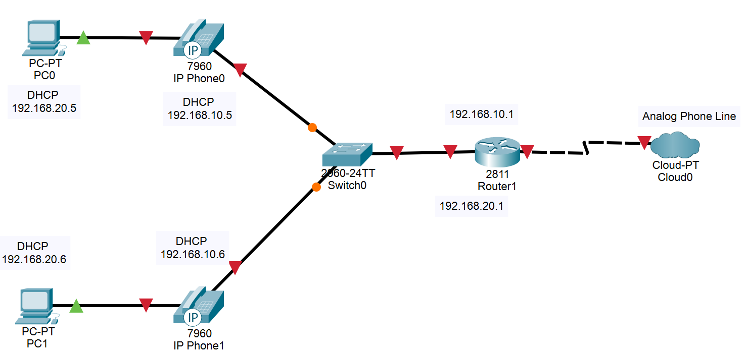  
***Configurations***

***R1:***

version 12.4

service timestamps debug datetime msec

service timestamps log datetime msec

no service password-encryption

hostname R1

boot-start-marker

boot-end-marker

no aaa new-model

resource policy

memory-size iomem 10

no network-clock-participate slot 1

ip subnet-zero

ip cef

no ip dhcp use vrf connected

ip dhcp excluded-address 192.168.10.1 192.168.10.5

ip dhcp excluded-address 192.168.20.1 192.168.20.5

ip dhcp pool voip

network 192.168.20.0 255.255.255.0

default-router 192.168.20.1

option 150 ip 192.168.20.1

voice-card 0

no dspfarm

voice-card 1

no dspfarm

interface FastEthernet0/0

no ip address

shutdown

duplex auto

speed auto

interface FastEthernet0/1

no ip address

duplex auto

speed auto

interface FastEthernet0/1.10

encapsulation dot1Q 10

ip address 192.168.10.1 255.255.255.0

no snmp trap link-status

interface FastEthernet0/1.20

encapsulation dot1Q 20

ip address 192.168.20.1 255.255.255.0

no snmp trap link-status

interface FastEthernet0/1.30

encapsulation dot1Q 30 native

no snmp trap link-status

interface FastEthernet0/1/0

interface FastEthernet0/1/1

interface FastEthernet0/1/2

interface FastEthernet0/1/3

interface FastEthernet0/1/4

interface FastEthernet0/1/5

interface FastEthernet0/1/6

interface FastEthernet0/1/7

interface FastEthernet0/1/8

interface Serial0/2/0

no ip address

shutdown

interface Vlan1

no ip address

ip classless

ip http server

no ip http secure-server

control-plane

voice-port 0/3/0

voice-port 0/3/1

voice-port 0/3/2

voice-port 0/3/3

voice-port 1/0/0

voice-port 1/0/1

dial-peer voice 99 pots

destination-pattern 91[2-9].........

port 0/3/3

forward-digits all

telephony-service

max-ephones 2

max-dn 3

ip source-address 192.168.20.1 port 2000

system message if you can read this the phone is working

create cnf-files version-stamp Jan 01 2002 00:00:00

max-conferences 8 gain -6

ephone-dn 1

number 1921

ephone-dn 2

number 1922

ephone 1

mac-address 0015.2B47.6685

type 7960

button 1:1

ephone 2

mac-address 0015.62B5.E72C

type 7960

button 1:2

line con 0

line aux 0

line vty 0 4

login

scheduler allocate 20000 1000

end

***S1:***

version 12.2

no service pad

service timestamps debug uptime

service timestamps log uptime

no service password-encryption

hostname the_switch

no aaa new-model

vtp domain CCNP

vtp mode transparent

ip subnet-zero

no ip domain-lookup

no file verify auto

spanning-tree mode pvst

spanning-tree extend system-id

vlan internal allocation policy ascending

vlan 10

name Data

vlan 20

name Voice

vlan 30

name Native

vlan 40

name MISC

vlan 50

name NATIVE

vlan 99

name MANAGEMENT

interface FastEthernet0/1

switchport trunk encapsulation dot1q

switchport trunk native vlan 30

switchport mode trunk

interface FastEthernet0/2

switchport access vlan 10

switchport mode access

switchport voice vlan 20

mls qos trust cos

spanning-tree portfast

interface FastEthernet0/3

switchport access vlan 10

switchport mode access

switchport voice vlan 20

mls qos trust cos

spanning-tree portfast

interface FastEthernet0/4

interface FastEthernet0/5

interface FastEthernet0/6

interface FastEthernet0/7

interface FastEthernet0/8

interface FastEthernet0/9

interface FastEthernet0/10

interface FastEthernet0/11

interface FastEthernet0/12

interface FastEthernet0/13

interface FastEthernet0/14

interface FastEthernet0/15

interface FastEthernet0/16

interface FastEthernet0/17

interface FastEthernet0/18

interface FastEthernet0/19

interface FastEthernet0/20

interface FastEthernet0/21

interface FastEthernet0/22

interface FastEthernet0/23

interface FastEthernet0/24

interface GigabitEthernet0/1

interface GigabitEthernet0/2

interface Vlan1

no ip address

shutdown

ip classless

ip http server

control-plane

line con 0

line vty 0 4

no login

line vty 5 15

no login

end

***Screenshots***

*Illustrated below is a ping from the PC towards the router done to test connectivity through the phone to the router.*

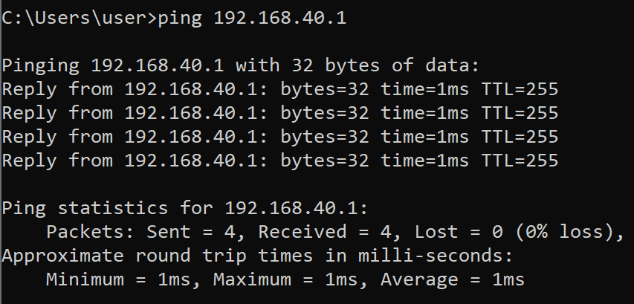  
*Illustrated below is a ping from the PC1 towards PC2 done to test connectivity across the network and verify phone interconnectivity.*

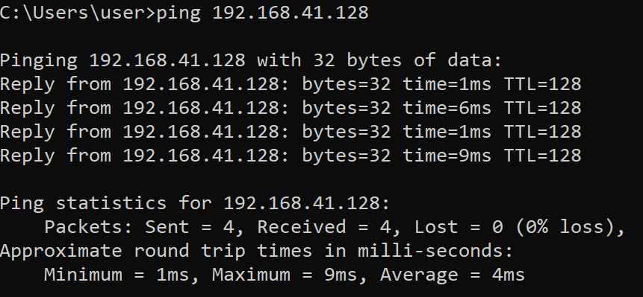

*Illustrated below is a configured phone complete with a number for internal calling and a system message.*

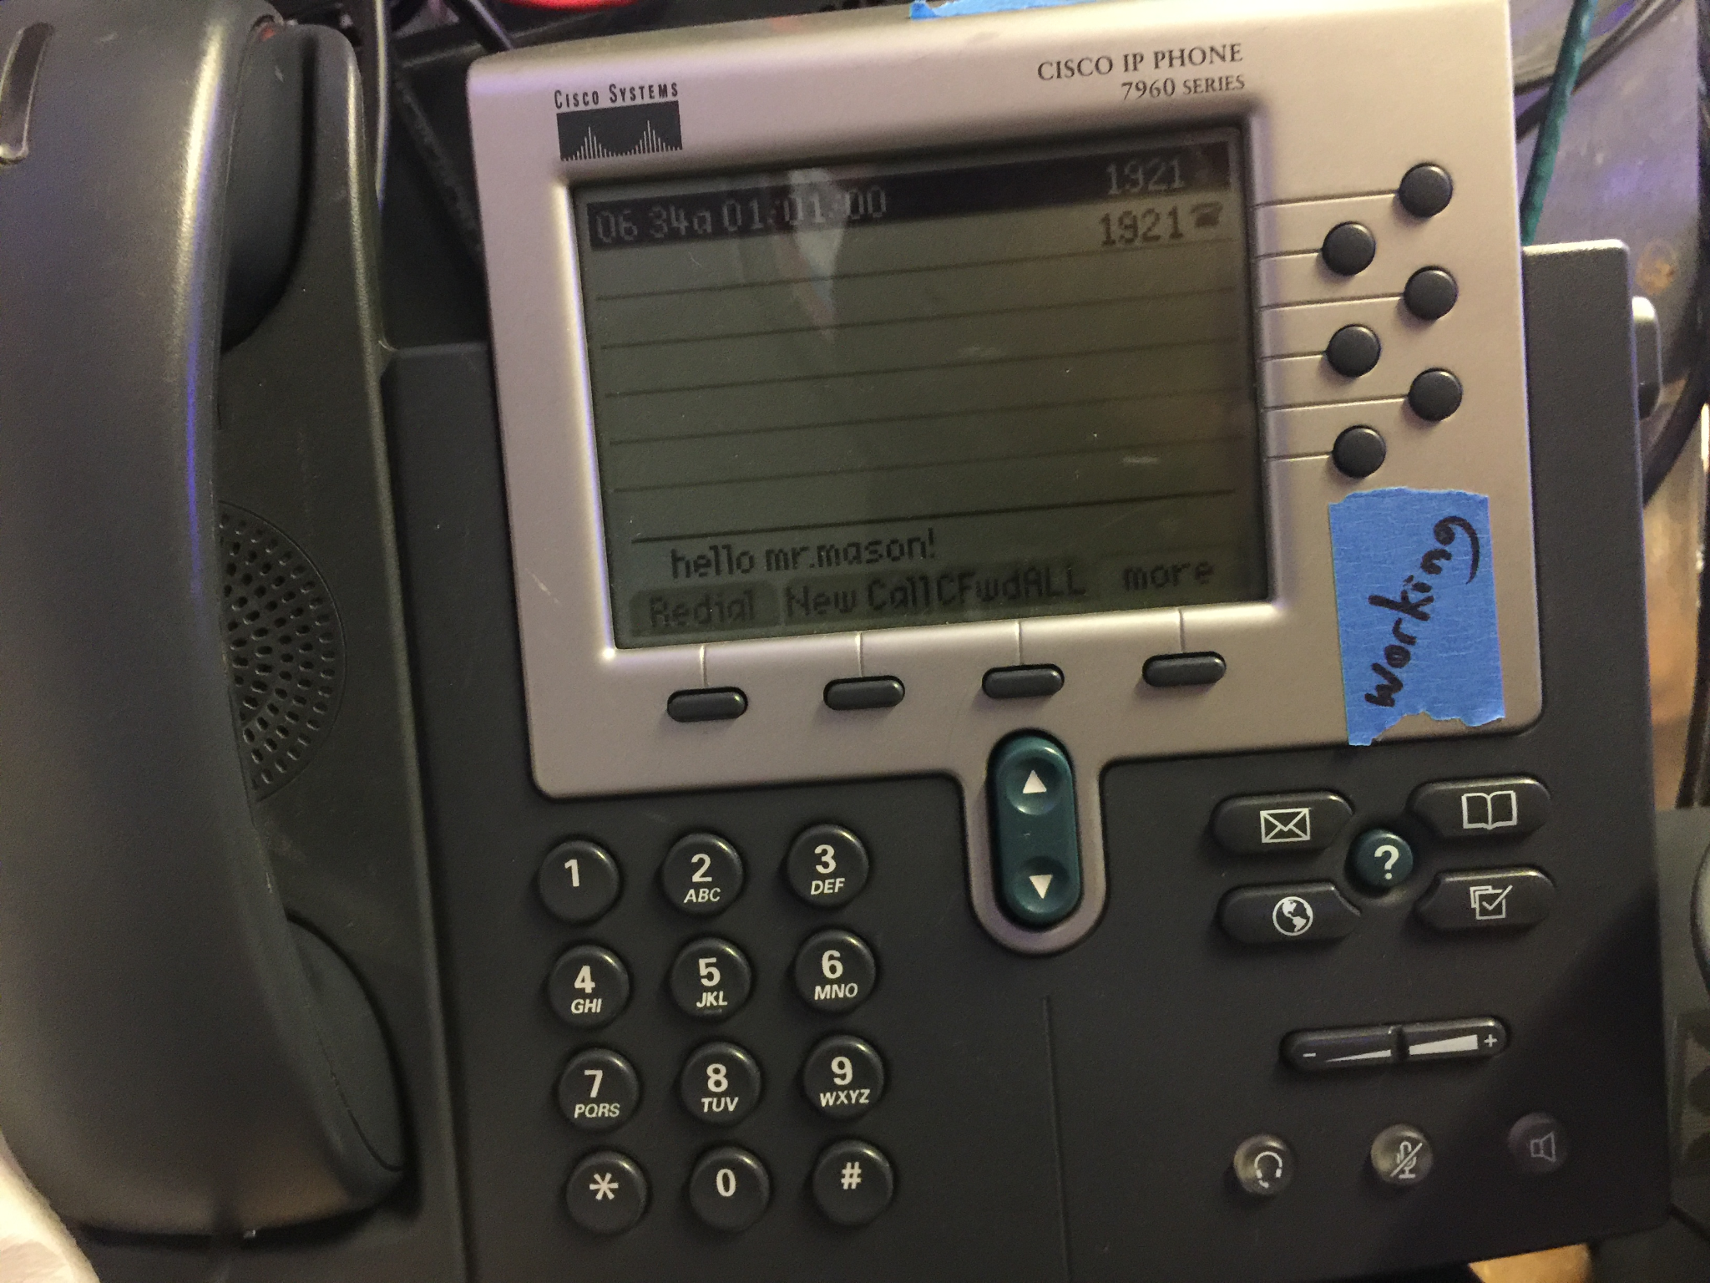

***Problems***

As we began investigations as to how to complete the lab, the first issue we ran into was installation of CME on the Integrated Series router to allow for communication between the phones, this was fixed by installing the CME software after downloading it from the Cisco page. In addition, certain phones wouldn’t work as they would not receive the configuration file from the router, required to use the phone itself. As well as the usage of an incorrect command, which would not forward all the digits in a phone number to the PSTN office. Furthermore, there were many commands which we investigated which were unnecessary for the lab and caused additional confusion.

***Conclusion***

In the end, I gained an understanding of the applications of separating traffic to multiple vlans and how calling worked over IP. Along with a comprehension of how POTS and how PSTN works to provide public communication. As well as how complex of a process phone communications is to configure, even just internally.